Programming Concepts  
Week 6 **Credit** Submission Tasks Template

Student ID: ______103055993_______________

Student Name: ________Mario Stavreski______________________

## Credit Task 15 HTML code

Paste the HTML code of the web page here.

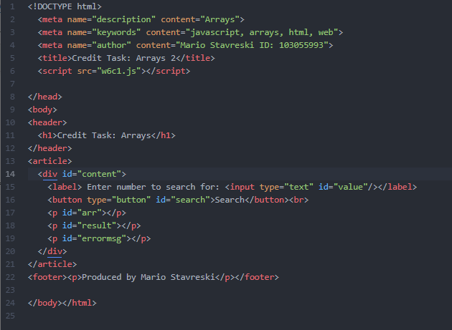

## Credit Task 15 JavaScript code

Paste the JavaScript code of the same page here.

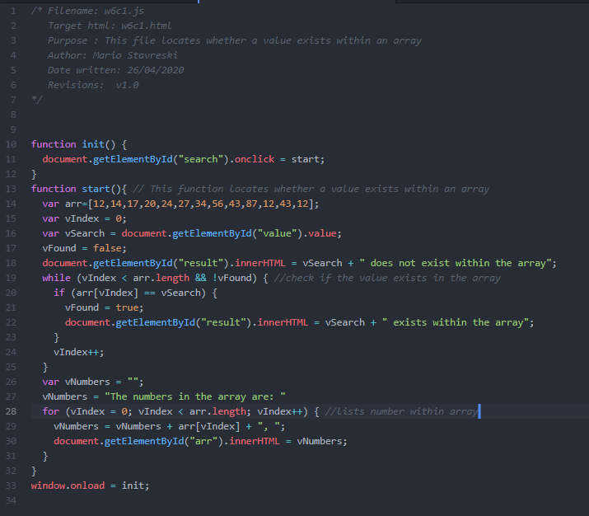

## Credit Task 15 web page testing (at least 4 tests as per the handout)

Paste the screen captures of your testing web page here.

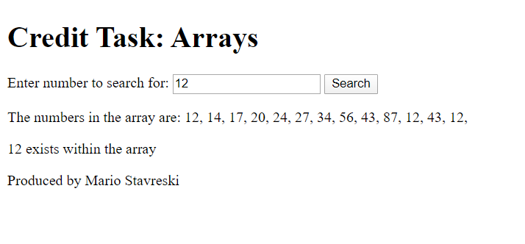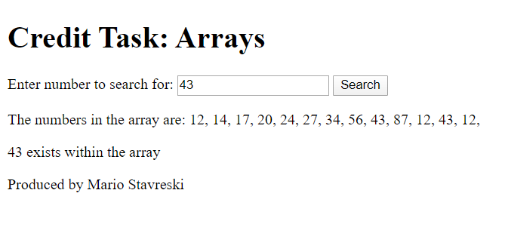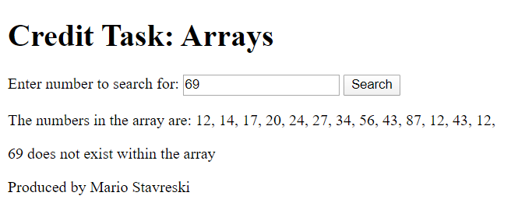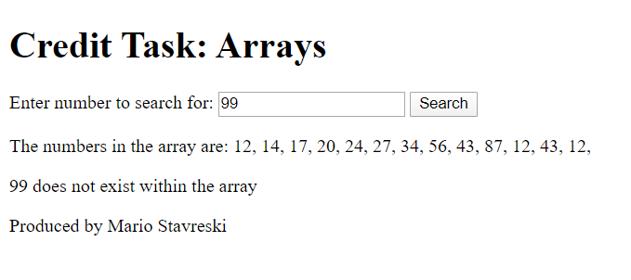

## Credit Task 16 HTML code

Paste the HTML code of the web page here.

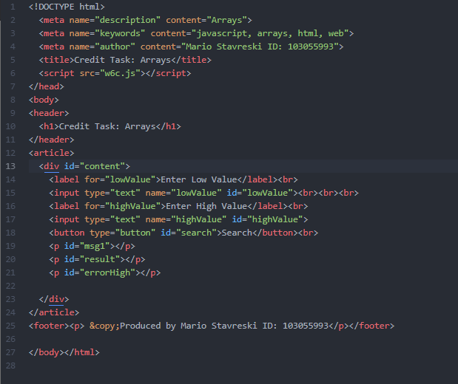

## Credit Task 16 JavaScript code

Paste the JavaScript code of the same page here.

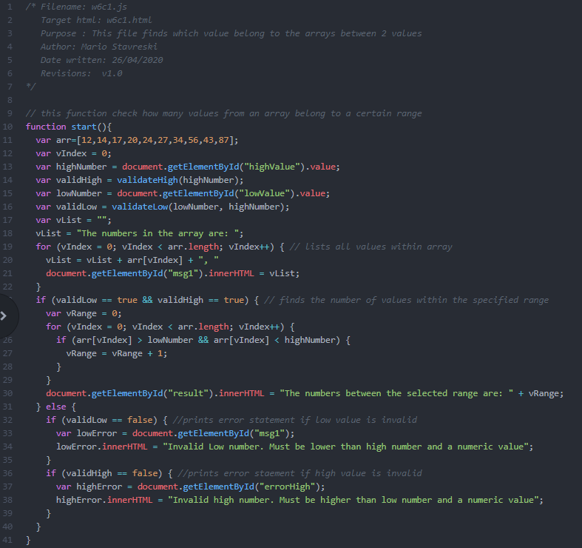

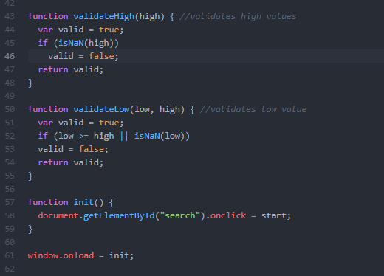

## Credit Task 16 web page testing

Paste the screen captures of your testing web page here.

